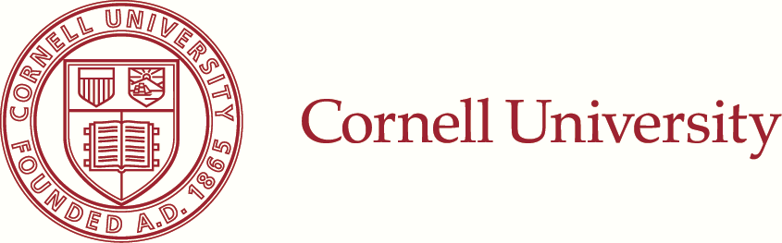
School of Chemical and
Biomolecular Engineering
120 Olin Hall
Ithaca, New York 14853-5201
t. 607.255.8656
f. 607.255.9166
March 20, 2013
Yi Liu
No.1, Ln. 75, Shuiyuan Rd.
Sanmin Dist., Kaohsiung City
Kaohsiung, TAIWAN
Dear Yi:
On behalf of the Graduate Professional Programs Committee, I am pleased to inform you that you have been admitted
to the Engineering Division of the Graduate School for the Fall 2013 term as a candidate for the Master of Engineering
(Chemical) Degree.
Your admission is contingent upon certification of adequate financial resources to complete this degree program. We
are unable to send you the Certificate of Eligibility (Form I-20) until we are certain that you have the necessary funds to
pursue graduate work at Cornell and we receive a photocopy (or scanned copy) of your passport. Attached you will find
a Financial Responsibility Form (FRF) from the Cornell Graduate School. Please complete and submit it (along with bank
documents or sponsor confirmation) to: Cornell Graduate School, 143 Caldwell Hall, Ithaca, NY 14853.
Although your application has been acted upon at this time, final admission is contingent upon satisfactory completion
of your baccalaureate program with academic performance comparable to that completed to date and receipt in this
office of a transcript containing certification of your degree.
If you have any questions, please do not hesitate to contact me or Shelby. Shelby can best help you with administrative
questions (housing, travel, etc.), while I can help you with questions concerning the educational aspects of the program.
Please visit the Cornell Graduate School Response Form as soon as possible (and no later than April 15) to let us know
your decision:
www.gradschool.cornell.edu/response
We will be pleased to have you in the Master of Engineering Program and will try to make your graduate experience at
Cornell as educationally rich as possible.
Sincerely,

aaaaaaaaa
William Olbricht
Professor & Master of Engineering Representative

